1. Follicle stimulating hormone is released from the

(a) ovaries.

(b) testes.

(c) corpus luteum.

(d) pituitary gland.

2. A Pap smear is a test that can be used to identify abnormal cells that could lead to the development of

(a) cervical cancer.

(b) prostate cancer.

(c) bowel cancer.

(d) breast cancer.

3. An imbalance in the action of osteoblasts and osteoclasts can most likely lead to the onset of which of the following disorders?

(a) osteoarthritis

(b) bone cancer

(c) osteoporosis

(d) rheumatoid arthritis

4. Which of the following correctly describes the importance of informed consent when carrying out an investigation involving human trials?

(a) Everyone has the right to have their identities kept confidential.

(b) Everyone has the right to know the possible risks, potential benefits and the objectives of the investigation.

(c) Nobody should be pressured into taking part in the investigation.

(d) Everyone has the right to remain anonymous throughout the investigation.

5. After a 12-week ultrasound a young couple were informed that there was a high probability of their baby being born with a chromosomal abnormality. The couple decided to get a diagnostic test to allow them to be better informed and prepared for the outcome at birth. Which of the following tests would the couple be able to get at this week of the pregnancy?

(a) chorionic villus sampling

(b) fetoscopy

(c) preimplantation genetic testing

(d) amniocentesis

6. Athletes have an increased risk of wearing away the cartilage found on the epiphyses of the bone that allow for smooth, frictionless movement. This can lead to a condition known as

(a) rheumatoid arthritis.

(b) spondyloarthritis.

(c) osteoarthritis.

(d) bursitis.

7. Which of the following correctly describes a difference between the processes of spermatogenesis and oogenesis?

(a) Spermatogenesis produces 4 mature haploid cells while oogenesis produces 1 mature haploid cell.

(b) Spermatogenesis occurs in the interstitial cells of the testes while oogenesis occurs in the ovaries.

(c) Spermatogenesis produces 4 haploid cells while oogenesis produces 1 diploid cell.

(d) Spermatogenesis produces polar bodies while oogenesis does not.

8. The outer layer of cells that spermatozoa break through in order to enter the cytoplasm of the ovum is known as the

(a) corpus luteum.

(b) zona pellucida.

(c) acrosome.

(d) corona radiata.

9. A man with Huntington’s disease and a woman without Huntington’s have two children. After genetic testing it is determined that one of their children will develop Huntington’s when they’re older, while the other is genetically healthy. What is the percentage probability of the couple having another child with Huntington’s disease?

(a) 25%

(b) 75%

(c) 50%

(d) 100%

10. The following points describe the steps, out of order, in the sliding filament model that explains the contraction of skeletal muscles from the point where the muscle cells are stimulated by a nerve cell.

(i) Myosin heads bind to actin forming a myosin cross-bridge

(ii) The myosin head bends and ADP and phosphate are released, pulling the actin over the myosin

(iii) Calcium ions enter the muscle cells and the presence of calcium exposes the myosin binding sites on the actin molecule

(iv) A new molecule of ATP attaches to the myosin and the cross-bridge detaches

Which of the following indicates the steps in the correct order?

(a) (i), (ii), (iii), (iv)

(b) (iii), (i), (iv), (ii)

(c) (i), (iii), (iv), (ii)

(d) (iii), (i), (ii), (iv)

11. Fertilisation typically takes place in the

(a) ovaries.

(b) cervix.

(c) uterus.

(d) uterine tubes.

12. Which of the following does **not** describe a structure of the alveoli that make them suited to the process of gas exchange?

(a) The alveoli are one-cell thick.

(b) The alveoli contain approximately 21% oxygen concentration from inhaled air.

(c) The alveoli are surrounded by a rich supply of blood capillaries.

(d) The alveoli are surrounded by a thin layer of moisture

Questions 13, 14 and 15 refer to the following diagram of the human male reproductive system.

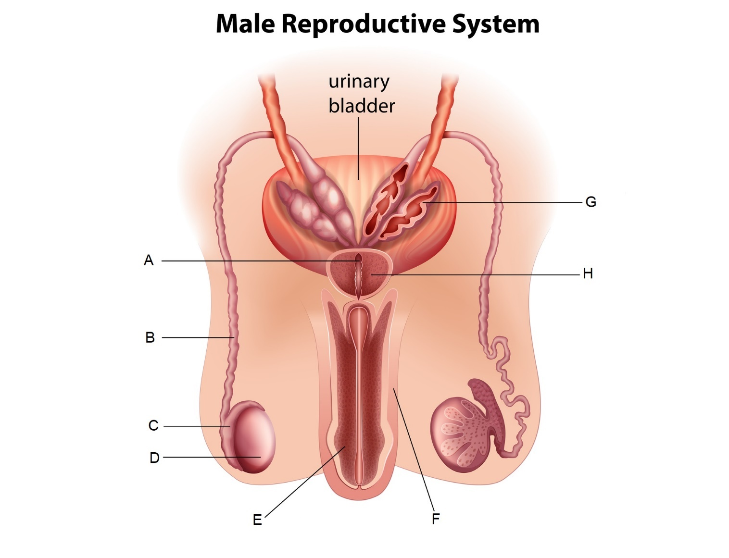

13. Which of the following labels indicates the epididymis?

(a) A

(b) B

(c) C

(d) D

14. Which of the following most correctly describes the function of the part labelled H?

(a) It secretes a fluid rich in sugars that makes up the majority of the seminal fluid.

(b) It secretes a small amount of fluid that acts as a lubricant.

(c) It secretes an alkaline fluid that helps to neutralise the acidity in the vagina.

(d) It secretes a fluid rich in proteins to provide spermatozoa with strength for swimming.

15. A relatively simple surgical procedure to sterilise males and prevent conception usually involves which of the following parts?

(a) A

(b) B

(c) C

(d) D

Questions 16, 17 and 18 refer to the following information.

Deidre and Georgina are conducting an investigation to see the change in mass of cylinders of potatoes when placed in varying concentrations of sucrose solutions. They find that when the potatoes are placed in distilled water they tend to increase in mass, while those placed in concentrated sucrose solutions tend to decrease in mass.

16. Which of the following correctly identifies the dependent variable in this investigation?

(a) the concentration of sucrose

(b) the change in mass of the potato

(c) the volume of sucrose solution

(d) the final mass of the potato

17. If one cylinder of potato in a highly concentrated sucrose solution has an initial mass of 1.55 g and a final mass of 1.44 g, which of the following correctly states the percentage change in mass?

(a) 11% increase

(b) 7% increase

(c) 11% decrease

(d) 7% decrease

18. Which of the following best explains why the potatoes in distilled water increased in mass?

(a) The sucrose moved into the potato through diffusion to balance out the concentration of sucrose in the potato and the water.

(b) The water had a higher solute concentration than the potato, so the water moved into the cells of the potato through osmosis.

(c) The potato had a higher solute concentration than the distilled water, so the water moved into the cells of the potato through osmosis.

(d) The cells of the potato gained mass as the starch inside was diluted by the distilled water.

19. During the process of flexion at the knee, the hamstring is contracting and the quadriceps are relaxing. Which of the following correctly describes the relationship between these two groups of muscles during this movement?

(a) The hamstring is the agonist while the quadriceps are the antagonists.

(b) The hamstring is the antagonist while the quadriceps are the agonists.

(c) The hamstring is the synergist while the quadriceps are fixators.

(d) The hamstring is the fixator while the quadriceps are synergists.

20. Pairs of homologous chromosomes line up together at the equator during

(a) metaphase.

(b) metaphase I.

(c) metaphase II.

(d) anaphase I.

21. With regards to inheritance of ABO blood groups, which of the following correctly identifies the mode of inheritance for the allele that results in no antigens presenting on the erythrocytes?

1. X-linked recessive

(b) X-linked dominant

(c) Autosomal dominant

(d) Autosomal recessive

22. In a healthy, functioning nephron, active reabsorption of glucose **mostly** occurs in the

(a) proximal convoluted tubule.

(b) renal corpuscle.

(c) loop of Henle.

(d) distal convoluted tubule.

23. Glucose is a relatively large, water-soluble molecule that cells consistently use up during the process of cellular respiration. Glucose would most likely pass through the cell membrane through which of the following processes?

(a) osmosis

(b) simple diffusion

(c) facilitated diffusion

(d) active transport

24. Which of the following embryonic membranes will eventually form the foetal portion of the placenta?

(a) the chorion

(b) the amnion

(c) the yolk sac

(d) the allantois

25. After the first meiotic division during oogenesis, one of the cells created is smaller than the other with very little cytoplasm, while the other is larger and contains most of the cytoplasm. These two cells are, respectively, referred to as the

(a) first polar body and secondary oocyte.

(b) first polar body and primary oocyte.

(c) second polar body and secondary oocyte.

(d) second polar body and primary oocyte.